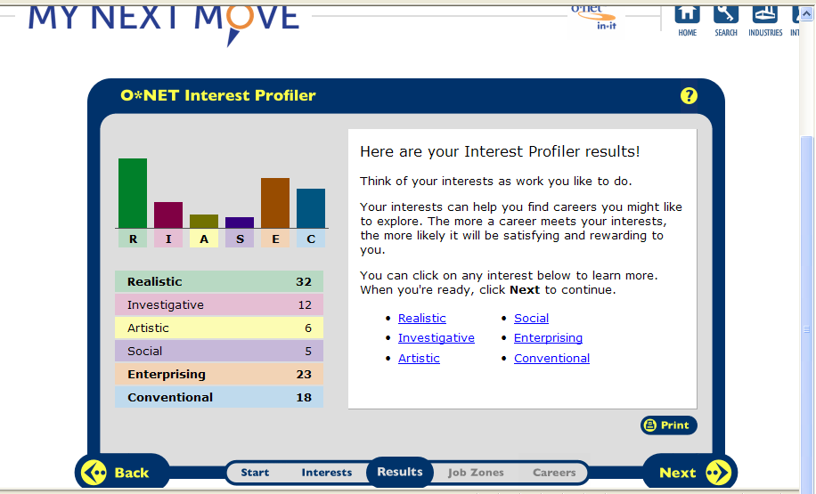
After taking the survey/ test, my most popular result was realistic. The main idea of a realistic career type is basically hands-on-work. After reading what the description says about the realistic career type, I feel that only some of the information applies to me. However the ones that apply to me are: refinishing furniture, taking exercise classes, playing sports, woodworking, coaching teams, repairing equipment, and even landscaping. Those topics are some that are in great interest with me. I enjoy doing hands-on-work, especially since I have had the experience doing so for the past five years now. Although there are many things that I like about the options they gave me, there were a few things listed that I was not interested in at all. Those being: growing plants or flowers, hunting or fishing, and bird watching. Options like those do not really fit my personality and or my likings. That is how I believe the realistic category fits the way my personality actually is and what I have planned in my future.
Landscaping-
- To improve the appearance by changing its features and adding various items to it. The nature of doing landscaping is to basically take out the old and put in the new. Or other options consist of renovating and or adding different things to change the whole look of something.
- Some related fields would be architects and designers.
- Personality types would include doing hands-on-work and exploring things first hand.
- An education for landscaping is not really needed. Most companies hire people to work for them and as times goes on they start to learn more and more about the trade itself.
- Some of the technology skills needed to be successful in this career would be to make sure that you are very good and talented in landscaping. The reason being is because in order to make more money in this business and to succeed you have to learn the trade very well and become pristine in your work.
- In May 2008, median annual wages for landscape architects were $58,960. The middle 50 percent earned between $45,840 and $77,610. The lowest 10 percent earned less than $36,520 and the highest 10 percent earned over $97,370.
Occupational Title | SOC Code | Employment, 2010 | Projected  Employment, 2020 | Change,  2010-20
 |  |  |  | Number | Percent
Landscape architects | 17-1012 | 26,700 | 32,000 | 5,300 | 20

- 3 local businesses’ that would hire are: All Seasons, J H Landscaping, Gc Landscaping.
- For landscaping most companies work from sun rise to sun set. The reason being is because in the summer, that’s when their business’ are at its highest peak. However in the winter time they work usually plowing streets. Work conditions include working outside at all times.
- Landscaping jobs can be included in the union if they are a big company. The reason being is because the union hires some companies to join them and work under them, such as towns and cities. Small private owned business’ are not in the union.
- In the landscaping filed there is room to grow. Although the room isn’t all that big because, you can real only advance in better job and or beginning your own company.

Security guard-
- A security guard is someone who keeps watch. The nature of doing this would be to look out and protect your grounds and everything around you.
- Some related occupations would be a cop, correctional officer.
- The personality types for this occupation would be to have a protective state of mind. You should be able to know how to protect and control your surroundings.
- When you want to become a security guard, there is not any certain education requirement that is needed in order to become one. Any guards that are going to work in the government have to have had some experience in the field, pass a written test, and pass a fire arms course test. Other guards applying for non-government jobs have to pass other various courses.
- Some skills that would be required for this job would be to make sure you are familiar with using guns and are ok with protecting people. Also, in some cases you have to be ready and willing to put your life on the line if the time comes.
Percentile | 10% | 25% | 50%  (Median) | 75% | 90%
Hourly Wage | $8.23 | $9.39 | $11.50 | $14.92 | $19.83
Annual Wage (2) | $17,130 | $19,540 | $23,920 | $31,030 | $41,240

- The growth in this field will continue to be high because there is always going to be a need for a security guard. Something is always going to have to be protected and watched.
- 3 local security jobs: Internal security Associates, Dunbar Armored, Allied Barton Security Services.
- Working conditions may conclude both inside and outside work, depending on where and what the job is. Most security guards have over-night shifts where they have to just stay and watch for the whole night. Others have day jobs. According to where you work
- Some security jobs are considered in the union only if you are working for the government and or if you are working for a big company. Most security jobs are either for the government. If it not for the government then usually they are used in small business’
- The opportunities for this career would be to get a job making better money. The way someone could do that is if they worked for a small business and then upgraded and started working for the government and made more money.
Construction-
- Construction- the building of something, typically a large structure.
- Some related occupations that are related in the construction field are: carpenters, plumbers, electricians.
- The personality type for a construction worker would be all 100% hands-on-work. Building things using your hands and other hand tools.
- Depending on what kind of construction you are participating in, the education varies. However you don’t really need a certain education for most, usually in you are interested you pick up all of the trades and skills yourself.
- Some skills that would be needed in order to be in the construction business would be to make sure that you can work in any condition. Also make sure that you are well aware of what you’re doing. Always know how to use a tape measure, how to use common tools and what to use them for.
- Median hourly wages of wage and salary construction laborers in May 2008 were $13.71. The middle 50 percent earned between $10.74 and $18.57. The lowest 10 percent earned less than $8.67, and the highest 10 percent earned more than $25.98.
Occupational Title | SOC Code | Employment, 2010 | Projected  Employment, 2020 | Change,  2010-20
 |  |  |  | Number | Percent
Construction laborers | 47-2061 | 1,248,700 | 1,504,600 | 255,900 | 20

- Local companies that would be willing to hire are : Somerset Construction, J.k. Construction.
- Working conditions for this career would mostly include outside work during the cold and warm weather. And during the rain and or stormy days mostly inside work. However some companies vary.
- There are a lot of construction jobs that are in the union. Also a lot of companies work for the towns and cities.
- The advancement for being in the construction field would be to open up your own company and or get a job working for the union.
Carpenter-
- A carpenter is a person who makes and repairs wooden objects and structures.
- Some related jobs would be maintenance jobs, repair jobs.
- Personality types for this occupation would include doing finish work and hands-on work.
- Vocational schools and technical colleges offer certificate and associate's degree programs in general carpentry or in different carpentry crafts. A technical college program uses classroom instruction to teach building codes and layout, construction drawings and blueprint reading.
- Technology skills needed to become a carpenter is craftsmanship.
- In May 2008, median hourly wages of wage and salary carpenters were $18.72. The middle 50 percent earned between $14.42 and $25.37. The lowest 10 percent earned less than $11.66, and the highest 10 percent earned more than $33.34
Occupational Title | SOC Code | Employment, 2010 | Projected  Employment, 2020 | Change,  2010-20
 |  |  |  | Number | Percent
Carpenters | 47-2031 | 1,284,900 | 1,450,300 | 165,400 | 13

- The projected growth in this field is to be increased because there is always going to be work needed to be finished and done nicely like a carpenter.
- Some local places that would hire are : Home Improvement, Renovation & Repairs
- Working conditions for this job are not bad at all. However the work you have to do is very precise and has to be done perfect.
- Yes there a few jobs that are in the union but most of them are just small owned business’.
- In this filed, there really is not much room to get promoted. The only way you could is if you somehow start to get more jobs and make more money.

Roofer-
- The definition of a roofer is a person who constructs and or repairs roofs.
- Some related careers would be: someone who does tile floors, or builds roofs.
- Personality types for this job would be someone who isn’t afraid of heights and isn’t scared to climb ladders and be up on a roof.
- There is no education that is needed to become a roofer; however you must learn and know the skill very well and become properly trained.
- Technology skills needed to become a roofer would be to know how much shingles cost. Also how to estimate the amount of shingles that are needed to be put down per square foot.
- In May 2008, median hourly wages of roofers were $16.17. The middle 50 percent earned between $12.97 and $21.98. The lowest 10 percent earned less than $10.63, and the highest 10 percent earned more than $28.46. Median hourly wages of roofers in the foundation, structure, and building exterior contractors industry were $16.26. Earnings may be less on occasions when poor weather limits the time roofers can work.
Occupational Title | SOC Code | Employment, 2010 | Projected  Employment, 2020 | Change,  2010-20
 |  |  |  | Number | Percent
Roofers | 47-2181 | 148,900 | 154,600 | 5,700 | 4

- Local roofing business’ that would hire are: M. Bertoncini General Contracting, Certified Roofing.
- Working conditions for this job consist of mostly working from morning around 7:30-8:00 until late afternoon early evening 4:30-5:00. The work is obviously done outside and also varies with height and steepness.
- Some roofing companies are for the union, and some are personal owned businesses.
- A way to get promoted in this career would be only if you either expand your company or get into the union making more money.

Home appliance repairer-
- The definition of a home appliance repairer is also known as an in-home service professional, Home Appliance Repair Technicians service a variety of household durable goods, with the exception of cooling and central heating units.
- Related careers would be a any repair occupations.
- Personality types for this occupation are that you have to be very friendly and have good people skills.
- Education needed for this occupation would be hire graduates of technical appliance repair or electronics programs offered at post-secondary technical schools or community colleges. The Environmental Protection Agency requires that all technicians who work with refrigerants pass a written examination to become certified in the proper handling of these.
- Some technology skills needed is to be would be to know how to use tools and equipment efficiently. Also being able to have good people skills and be able to understand each and everything about house hold items.

Percentile | 10% | 25% | 50%  (Median) | 75% | 90%
Hourly Wage | $9.81 | $12.83 | $16.70 | $21.45 | $27.16
Annual Wage (2) | $20,400 | $26,690 | $34,730 | $44,620 | $56,500

Employment (1) | Employment  RSE (3) | Mean hourly  wage | Mean annual  wage (2) | Wage RSE (3)
33,180 | 3.4 % | $17.54 | $36,490 | 1.0 %

- Local places hiring : sears appliance repair, and Bobs appliance repair.

